**“FPO Marketplace & Conclave”**

**SIAET Campus, Bhopal MP**

**March 15, 2023**

 **Organized By Sponsored By Supported By**



Contents

Introduction 3

Objective 3

Value proposition for the participants 4

Event components 4

Participants’ Profile 5

Proceedings 9

Session-1: Inauguration of the event 9

Session-2: Release of Farmer Producer Organizations (FPO) Resource Book 11

Session-3: Inauguration of Market Exhibition 12

Session-4: Panel Discussions 15

Vote of Thanks 21

Outcomes- 22

Way ahead- 24

Follow up with Market functionaries for tie ups 24

Zoom meets for participants with market functionaries 24

Sending a note to ACS Agriculture for event proceedings and outcome 24

# Introduction

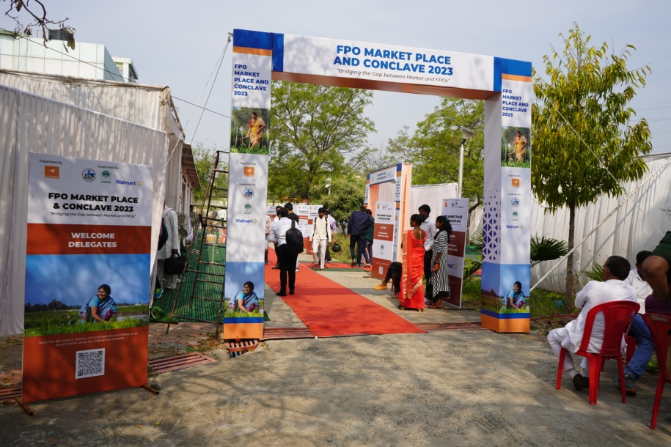A one day conclave was organized by ACCESS Development Services, New Delhi in collaboration with NABARD, Madhya Pradesh State Rural Livelihood Mission (MP SRLM) & Walmart Foundation. The conclave was attended by over 216 participants from FPOs across the state, FPO promoting agencies (CBBOs) along with government agencies, banks, financial institutions and various other stakeholders like traders, corporate buyers, input suppliers, agri-tech service providers, warehousing companies, tech-platforms, online marketing platforms etc.

## Objective

FPO Marketplace & Conclave is an attempt to create a platform which will function as a single window opportunity for the convergence between FPOs/FPO promoting agencies and other stakeholders in the agriculture value chain in farm sector. It will bring together FPOs and FPO promoting agencies across the state along with other stakeholders such as government agencies, exporters, traders, corporate buyers, input suppliers (seeds, farm equipment, fertilizers, pesticides), processors, banks,NBFCs, insurance companies, online marketing platforms, ag-tech service providers, warehousing companies, etc.

The marketplace aims to provide the opportunity and scope to FPOs and different stakeholders in the agricultural supply chain for:

* Active dialogue and engagement with one another to interface and negotiate mutually beneficial partnerships.
* Establishing forward and backward connections which will generate avenues for business development and expansion for FPOs.
* Acquiring information and direct access to the available financial services and schemes from Banks and Insurance Companies.
* Awareness generation of the various government policies and schemes specifically designed for the farm sector and FPOs.
* Bridge knowledge and information gaps through sharing of experiences and partnership models.
* Enhanced confidence of market players and service providers for transacting business with FPOs.

## Value proposition for the participants

The event has many value propositions for the participants.

* Business entities come at a large number in a common platform where FPOs can meet with them and strong their networking to set up market linkages pitches.
* Great opportunity for FPOs to learn about latest market trend and services in the industry, meet new suppliers, buyers.
* Getting the answer to your questions about FPOs business prospects.
* Chance to meet with various departments and know about the various schemes that are designed to benefit small farmers and their collectives.
* Unique opportunity for market functionaries to connect with the FPOs came from across the Madhya Pradesh State.
* Scope to buyers and the sellers to interact and exchange their thoughts. They exchanged their contact details for future communications.
* Market functionaries during interaction session at stalls discussed ways to improve networking for FPOs. Some ideas include having a signed MoUs between them& FPCs.

## Event components

The major components of the FPO Marketplace & Conclave were-

1. **Panel discussions on “Strengthening of FPO ecosystem in MP”, “Creating sustainable market linkages for FPOs” and “Financing FPOs”**

Panel discussions were designed to give a voice and facilitate active dialogue between various value chain partners on critical issues & challenges and discussing key opportunities.

1. **Release of FPO Resource Book- A compendium of potential FPOs capability**

The book is a compendium of capability profile of FPOs. This is designed to give exposure of FPOs capabilities to market functionaries so that the gap between them can be shorten. The FPO Resource Book shall be a pitch of all FPOs to market players to establish business relationship.

1. **Exhibition of products of FPOs**

This was kept in the event for showcasing various products that FPOs can supply to market. FPOs were invited to showcase their products (processed & unprocessed).

1. **Stalls by market functionaries**

Stalls were given to market players to showcase their product & services so that they can generate interest of FPOs in their business and a partnership can be developed.

1. **Introductory pitch by market functionaries**

This was envisaged to give FPOs an exposure of products and services available in the agriculture value chain.

1. **Networking meetings**

Dedicated networking area was kept in the event so that various stakeholders can meet and discuss business partnerships.

## Participants’ Profile

The event attended by over 215 participants from FPOs across the state, FPO promoters along with government agencies, banks, financial institutions and various other stakeholders like traders, corporate buyers, input suppliers, agri-tech service providers, warehousing companies, tech-platforms for enabling online trade etc.

|  |  |  |
| --- | --- | --- |
| **Sr. No.** | **Participants** | **Total Numbers** |
| 1 | Total Farmer Producer Organizations | 81 |
| 2 | CBBOs | 07 |
| 3 | Nationalized Bank | 01 |
| 4 | Private Bank | 01 |
| 5 | NBFC | 02 |
| 6 | Agri Input Companies | 07 |
| 7 | Agri Output Companies | 11 |
| 8 | Government Departments | 04 |
| 9 | NGOs & CSR Companies | 05 |
| 10 | Agri-Tech Platforms | 04 |
| 11 | Manufacturers | 03 |

**Farmer Producer Organizations**

**In total 145 participants from the representatives of 81 Farmer Producer Organization**s, promoted and supported by NABARD, MP DAY SRLM, ACCESS Development Services attended the FPO Marketplace & Conclave. In the table below, participants are briefly described.

|  |  |  |
| --- | --- | --- |
| **Sr. No.** | **Participants type** | **Participants Total** |
| **#** | **Total FPOs participated** | **81** |
|  | **Women FPOs** | **20** |
| 1 | Chief Executive Officer | 67 |
| 2 | Board of Directors& Chairperson | 55 |
|  | FPO Staff | 23 |
|  | Women BoDs | 24 |
| **Grand Total** |  | **145** |

**Marketing Partners**

**In total 42 participants from 27 companies such that** corporate buyers, input suppliers, agri-tech service providers, processors, online marketing platforms, warehousing companies, tech-platformsetc. participated in the event.

|  |  |  |  |
| --- | --- | --- | --- |
| **Sr. no.** | **Participants** | **Type of Entity** | **Brief** |
| 1 | Agribazaar (Star Agri) | Marketing Partners | Output market linkages, Input Market Linkages, e-Mandi, Warehousing |
| 2 | Dvara-E- Registry | Marketing Partner, Ag-Tech Platform | An AgriFinTech startup, offers multiple services like plot digitisation, crop analytics and advisory |
| 3 | SamunnatiAgro Solutions | Marketing linkage Partner | Aggregation, Market linkage, and advisory |
| 4 | National Bulk Handling Corporation | Market Linkage Partner | Integrated Services for Agri-commodities viz., Tech-enabled Procurement, Storage, Commodity Care, Collateral Management, and Supply-chain Solutions |
| 5 | NCDEX | Marketing Partner- Derivative marketing platform | Deals in commodity derivatives (futures, options) value chains |
| 6 | BSE E-Agriculture Markets (BEAM) | Electronic spot platform | Commodity spot trading, facilitates spot agri- commodities transactions across value chain consisting of producers, intermediaries, ancillary services and consumers |
| 7 | Modulus Housing | Infrastructure Development for FPOs | Strengthen FPOs Storage and Processing facilities to mitigate Post Harvest Loss |
| 8 | AgroNxt | Tech platform | Offer products and Services to enhance Productivity & Profitability of Farmers, Crop and Nutrition Advisory |
| 9 | Jain Irrigation | Micro Irrigation Company | Services from soil survey, engineering design to agronomic support in agricultural and irrigation development |
| 10 | IDH-The Sustainable Trade Initiative | Social Enterprise | Inclusive and sustainable market-driven solutions, works with businesses, financiers, governments and civil society to realize sustainable businesses |
| 11 | Swaraj Shree Chemicals | Input Marketing partners | Offers range of chemicals and advisory services |
| 12 | Mandi One/Waycool | Food &Agritech Company | Supply of staples, fresh produce and dairy products |
| 14 | Arya.ag | Agri Business Company | Grain commerce platform, connects sellers and buyers of agriproduce, Output Market linkage, e-Auction, booking warehouse, “Mandi bhav and Prakshep” services, offers warehouse receipt financing |
| 15 | Innotera | Agricultural technology service platform | Providing Market space to small holder farmers to the global food market; access to input and output products and services as well as to advisory and learning programs |
| 16 | Shakti Agrotech | Manufacturer and Agri Inputs | Manufacturer and supplier of top-quality agricultural equipment |
| 17 | Rudheesh Spices | Private Ltd. Company for commodity procurement | Commodity specially spices procurement from FPOs |
| 18 | Farmberry | Private Ltd. Company for commodity procurement | Procurement of organic produce of farmers |
| 19 | Verdesian Life Science (USA) | Agribusiness company | Advanced farming using advanced science |
| 20 | [SEPAL AGRITECH PRIVATE LIMITED Company](https://www.insiderbiz.in/company/SEPAL-AGRITECH-PRIVATE-LIMITED) | Agribusiness company | Transplantation of rice in rice fields. Horticultural and nursery services |
| 21 | Kubota Escorts | Manufacturers | Tractor and farm equipment manufacturer |
| 22 | Invest India | Promotion and facilitation agency | Promotion and facilitation agency for agriculture |
| 23 | NABKISAN | Subsidiary of NABARD | Financial products for Farmers’ Producers’ Organisations (FPOs) |
| 24 | Samunnati Agri Finance | Financial Linkage Partner | offers Agri Commerce solutions in addition to financial intervention |
| 25 | State Bank of India | Banking | Lending and other financial services to FPOs and members |
| 26 | HDFC Bank | Banking | Lending and other financial services to FPOs and members |
| 27 | AISECT | Social Enterprise | Skill Development, Higher Education, **Financial Inclusion**, e-Governance and other ICT-based services |

**Government Departments/Civil Societies/CBBOs**

In total 24 participants from 11 various Government Departments/Civil Societies/ CBBOs participated in the event.

|  |  |  |  |
| --- | --- | --- | --- |
| **Sr. no.** | **Participant Organization** | **Type of Entity** | **Brief** |
| **1** | **National Bank for Agriculture and Rural Development (NABARD)** | **Apex Bank** | **Agriculture Financing, Rural Development** |
| **2** | **MP DAY State Rural Livelihood Mission** | **Government Department** | **Poverty alleviation projects implementation** |
| **3** | Horticulture and Food Processing Department GoMP | Government Department | Horticulture and food processing |
| 4 | Centre Institutes of Agriculture Engineering (CIAE) | Central Institute of agriculture Engineering Institute | agriculture research and advisory services for farmers |
| 5 | Ravindra Nath Tagore University | Academics | Social work towards upliftment of marginalized people |
| 6 | Madhya Bharat Consortium Private limited | CBBO | State Level Farmers Producer Company, Promoted by SFAC, GoI, New Delhi |
| 7 | PRADAN- Professional Assistance for Development Action | Civil Society and CBBO | Grassroots level implementing non-profit organization |
| 8 | Centre for Advanced Research and Development | Civil Society and CBBO | Grassroots level implementing non-profit organization |
| 9 | Udyogini | Civil Society and CBBO | Work for marginalised, small landholders or landless women livelihoods |
| 10 | Anupam Education Society | CBBO | Formation and strengthening of Farmer Producer Organizations |
| 11 | Integrated Socio Economic Development Services (ISED) | CBBO | Formation and strengthening of Farmer Producer Organizations |
| 12 | Swami Vivekanand Society | CBBO | Formation and strengthening of Farmer Producer Organizations |
| 12 | Syngenta Foundation | Independent Organization | Agri Entrepreneur Model- (Linking Farmers to Markets, Providing knowledge on production, Facilitating purchase of agri-inputs) Improved production technologies for better productivity and higher incomes |

# Proceedings

## Session-1: Inauguration of the event

The chief guest of the event, Mr. Nirupam Mehrotra, Chief General Manager, NABARD, Regional Office, Bhopal, Madhya Pradesh along with other dignitaries inaugurated the conclave with the lighting of lamp.

**Detailing of the speeches by dignitaries:**

**Ms. Radhika Agashe, Executive Director, ACCESS Development Services**

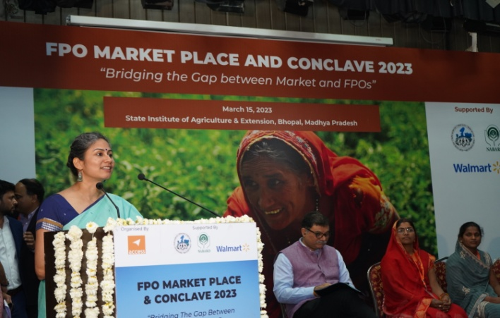The conclave’s welcome address was delivered by Ms. Radhika Agashe, Executive Director, ACCESS Development Services. She welcomed all the attendees present in the event and conveyed special thanks to the FPOs representatives, traders, corporate buyers, input suppliers, agri-tech service providers, warehousing companies, tech-platforms and institutional and technology partners. Further she gave brief about the event.

**Mr. Nirupam Mehrotra, Chief General Manager, NABARD RO MP**

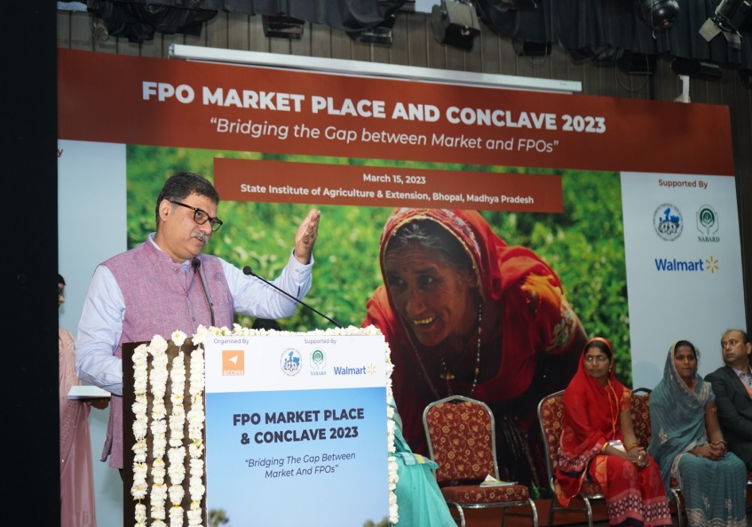In his address, Mr. Nirupam Mehrotra mentioned that the concept of FPO is to work together towards addressing the challenges faced by small and marginal farmer members. He informed that criteria have been set by GoI that there should be more than 300 members in the FPOs formed in plain areas. With more than 300 members, the chances of success of the FPO are enhanced. FPOs can be registered under both Companies and Cooperative Act. These rules should not be seen as binding, they should be considered necessary for smooth running of the company. FPOs can further add revenue streams to their business by way of Common Service Center (CSC). More than 400 services can be provided by FPO through CSC under Digital India.

He further added that ACCESS Development Services has developed a FPOs Resource Book for MP which was unveiled by him during the event. He emphasized that FPOs should focus primarily on output marketing as the revenue streams are higher for this business line. He also mentioned that raising of finances is an important aspect to accelerate their businesses. NABARD subsidiary, NAB KISAN meets the finance requirement of FPOs by way of term loan requirement and other loan products while NAB Sanrakshan provides the credit guarantees for FPOs’ financing. He concluded his remarks by thanking ACCESS Development Services for organizing this conclave and he emphasized that more such programs need to be conducted in future.

**Mr. Vipin Sharma CEO, ACCESS Development Services**

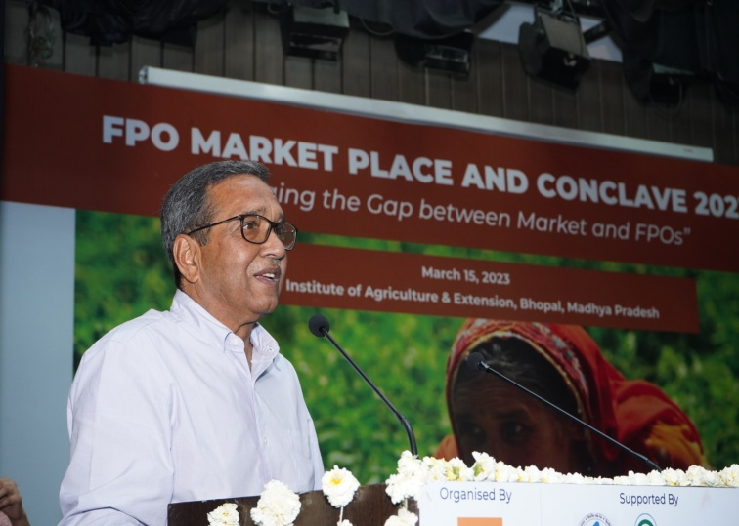Mr. Vipin Sharma, CEO, ACCESS Development Services, in his address informed that FPOs cannot be sustainable unless they are effectively integrated into the agri value chains. FPOs will gain if market participants and FPOs recognize and act upon the value of one another. He emphasized that in order to improve women's economic conditions, more attention should be paid to them in the FPO programmes. In order to create model women-owned FPOs, ACCESS is working to ensure that more FPOs formed where all of the shareholders are female. We already have some FPOs with a majority women ownership have already surpassed revenue of Rs. 1 Crore for the current fiscal year.

**Mr. Chintan Meghwanshi, State Manager MP, ACCESS Development Services**

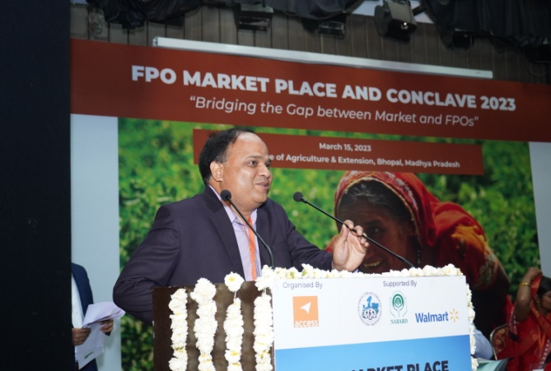Mr. Chintan briefed about the ACCESS work in the MP. He stated that ACCESS is closely working with FPOs associated with MP DAY SRLM and NABARD. ACCESS has served as Technical support agency value chain in MP DAY SRLM for last 2 years. The major responsibility of the TSA value chain was providing market linkages. ACCESS team has succeed in bringing 25+ market functionaries which include institutional buyers, NBFC, Traders, Ag tech service providers, Online marketing platforms, warehousing companies, etc. He mentioned that through TSA support 12 Cr business was done through FPOs. He informed that ACCESS is associated with NABARD through a watershed program. He informed that ACCESS is doing a very ambitious project in MP with the support from WALMART foundation and MP DAY SRLM. This project envisages building 10 FPOs a model FPOs. He mentioned the Model FPOs meaning. According to him, Model FPOs are those FPOs which have done something special in the area of agribusiness or community so that other FPOs can see them as role model. Some of the key attributes of Model FPOs are sustainable market linkages, robust governance system, strong financial linkages, enhanced participation of BoDs in decision making, increased percentage of women at management and governance level, viable business model, etc. He appreciated FPOs efforts in MP and gave commitment to support FPOs in market linkages.

## Session-2: Release of Farmer Producer Organizations (FPO) Resource Book

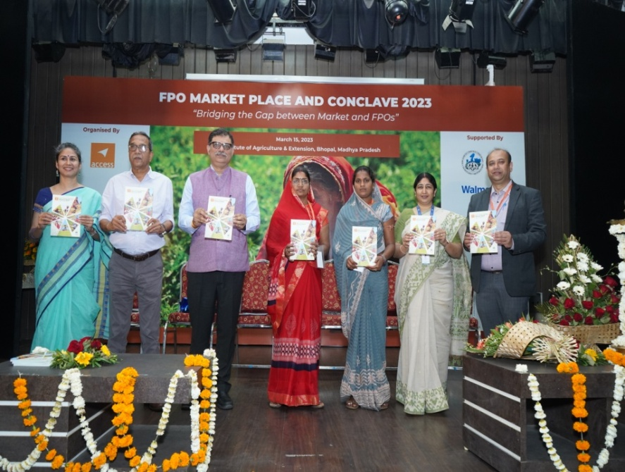

Moving to the next session of the event Farmer Producer Organization Resource Book was released by the chief guests of the event along with other dignitaries present in the event. The FPO resource book is compiled by Access Development Services and it demonstrates FPOs’ capabilities to deliver services to farmers and handle diverse businesses. This book gives exposure of FPO capacity to institutional buyers which in future convert in transactional business relationships.

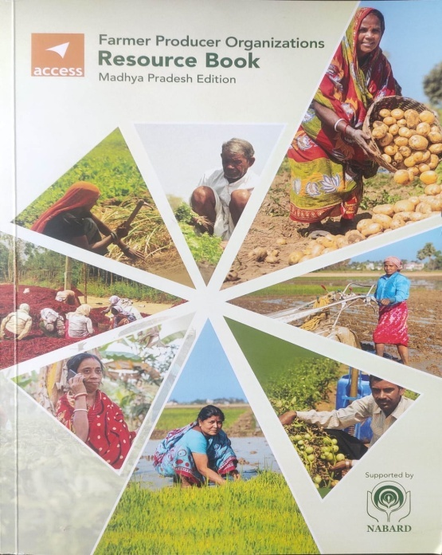This book is a compilation of FPOs basic profile as well as their institutional, business, infrastructural and financial capabilities. The book has potential to help buyers and departmentsto understand the capacities of FPOs in their operational areas and serve their interests and advocate for policies and programs that support their businesses. This book works as good reference by the participating ecosystem players to review the status of FPOs and approach the ones that align with their expectations. This document will also be useful for FPO promoters as resource for disseminating information about FPOs post the event.

Mr. Nirupam Mehrotra expressed his appreciation for ACCESS' initiative when he unveiled the FPO resource book.

FPO representatives also requested the Hindi version of the book during the question-and-answer sessions in order to improve inter-FPO cooperation.On which Vipin Sharma, CEO, ACCESS Development Services ensures to avail the Hindi version of FPO resource books to FPOs representatives in the following event, as well.

## Session-3: Inauguration of Market Exhibition

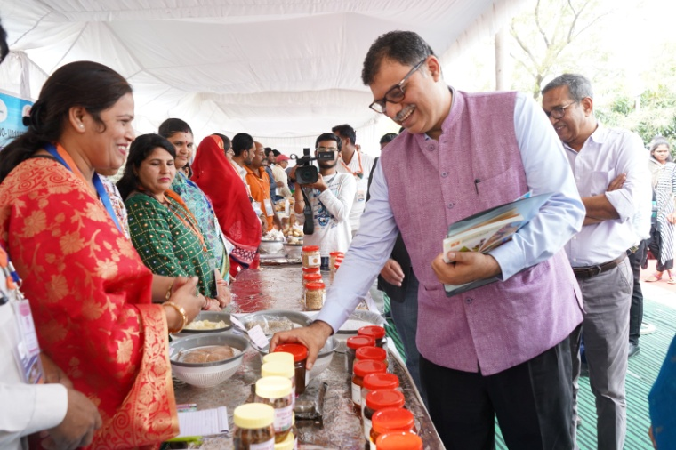The purpose of the Market Exhibition was first to showcase the market products and services to FPOs and secondly showcasing the FPOs’ crops, produces to the market functionaries and departments for fostering market linkages.

The chief guest of the event, Mr. Nirupam Mehrotra, CGM, NABARD cut the ribbon to officially open the market exposition. He along with the other dignitaries went to the booths and stalls set up by the farmer producer organisations and other market functionaries and spoke with them.

The following were the main highlights of the event's market exhibition:

* 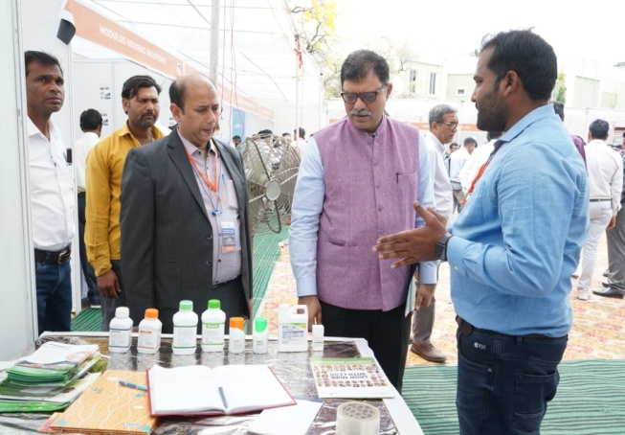The representatives of the FPCs, who set up a stall introduced about their FPOs current business, mentioning the major crops harvested in their region, future plan of enhancement and other business prospects.
* 7 Farmers Producer Organizations from various parts of Madhya Pradesh had set up the booths/stalls.
* FPOs representatives also discussed the grassroots challenges faced. Meanwhile participating Govt.Departments and various market partners and service platforms discussed the prospective solutions.
* Scope to buyers and the sellers to interact and exchange their thoughts. They exchanged their contact details for future communications.
* Market functionaries during interaction session at stalls discussed ways to improve networking for FPOs. Some ideas include having a signed MoUs between them& FPCs.

The list of the booths and stalls set up by the stakeholders is in the table below.

|  |  |  |  |
| --- | --- | --- | --- |
| **Sr.no.** | **Participant Organization** | **Type of Entity** | **Brief about demonstration** |
| 1 | Escorts Kubota Ltd. | Private Company/Startups | Product |
| 2 | Farmberry Agri. Solutions | Private Company/Startups | Services |
| 3 | Modulus Housing | Private Company/Startups | Services |
| 4 | Jain Irrigations | Private Company/Startups | Products |
| 5 | Agro star Technology Prv Ltd | Private Company/Startups | Services |
| 6 | Rudheesh Spices | Private Company/Startups | Processed Products |
| 7 | Surajshree Chemical Ltd. | Private Company/Startups | Products |
| 8 | AgroNxt Services Private Ltd. | Private Company/Startups | Services |
| 9 | FPO GCPCL Gohad Bhind | Farmer Producer Company | Commodities/Seeds/Processed Products |
| 10 | Mahila Kisan Crop producer Company Ltd. Sehore | Farmer Producer Company | Commodities/Seeds/Processed Products |
| 11 | Vijayganj Mandi Farmers Producer Company Ltd. Dewas | Farmer Producer Company | Commodities/Seeds/Processed Products |
| 12 | Shivoham FPC Guna | Farmer Producer Company | Commodities/Seeds/Processed Products |
| 13 | Bundelkhand Mahila Farmers Producer Company Ltd. Sagar | Farmer Producer Company | Commodities/Seeds/Processed Products |
| 14 | Onamasi FPC | Farmer Producer Company | Commodities/Processed Products |
| 15 | TekriMahila FPC Guna | Farmer Producer Company | Commodities /Processed Products |
| 16 | KundeshwarMillet FPCKundam | Farmer Producer Company | Processed Products |
| 17 | Madhya Pradesh Vigyan Sabha | TRIFED Bhopal supported | Processed products |

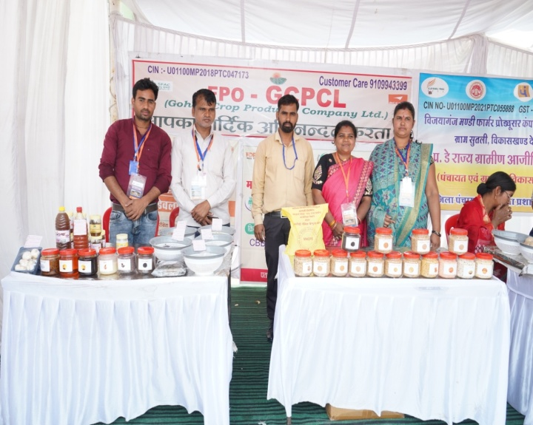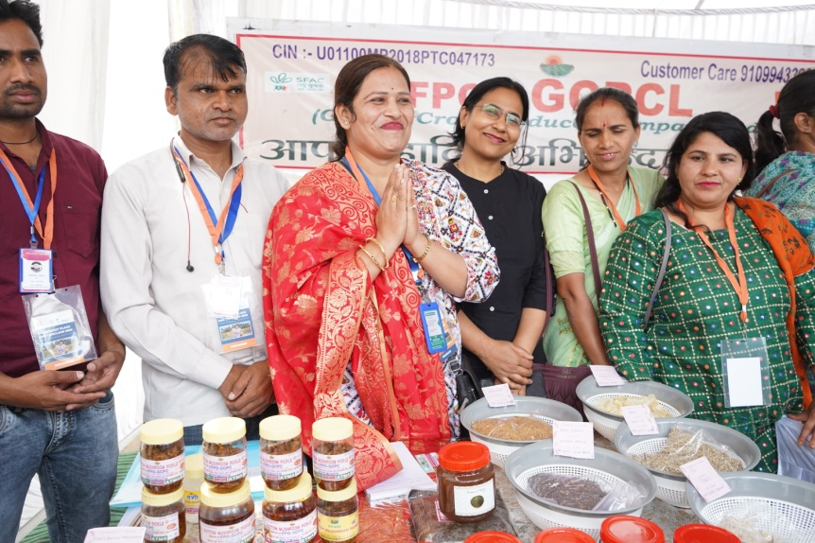

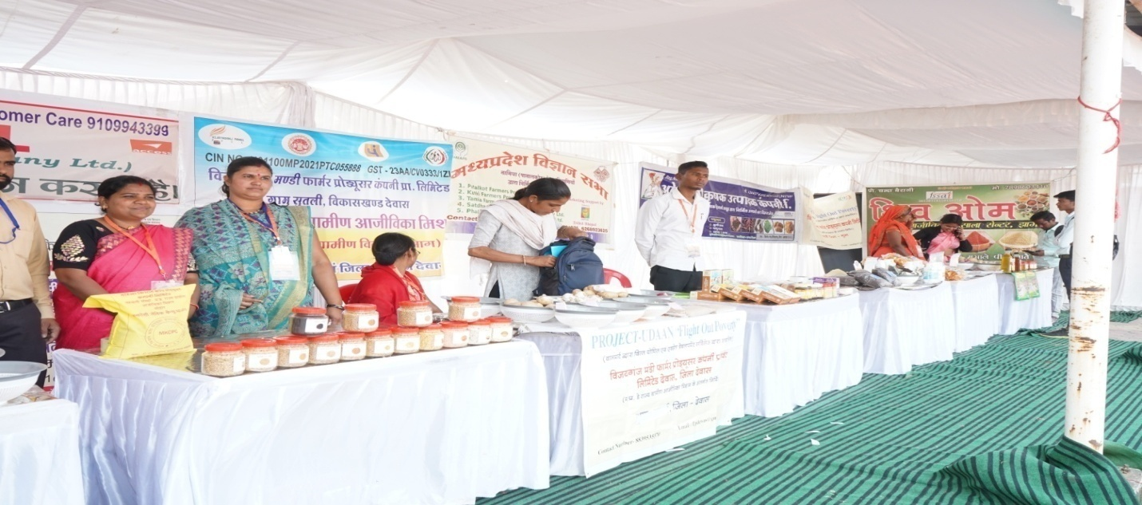

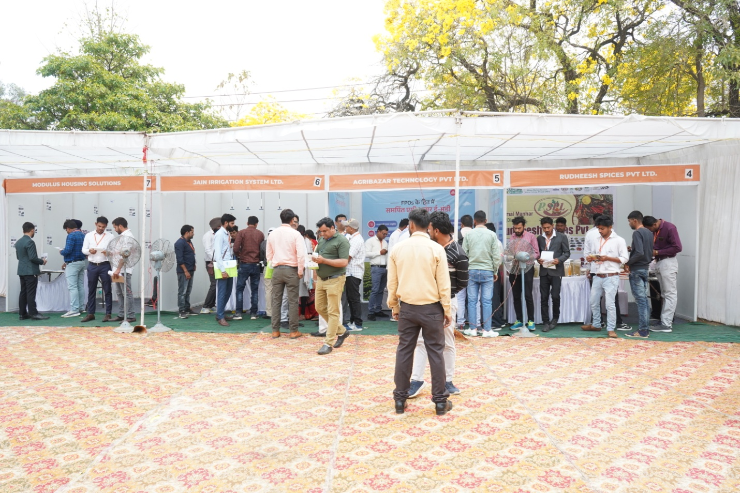

## Session-4: Panel Discussions

1. **“Strengthening the FPO Ecosystem in MP”**

**Panelist:**

* Prof. Manisha Pandey, Ravindra Nath Tagore University Bhopal (Moderator);
* 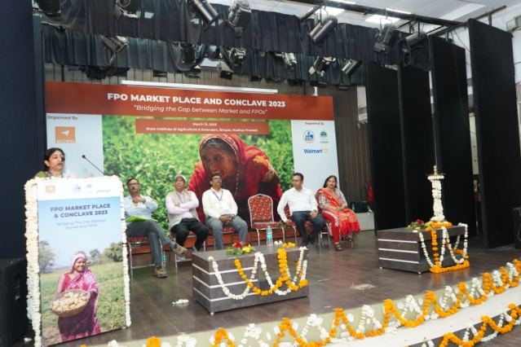Mr. Ravindra Nath, Integrator, PRADAN;
* Mr. Yogesh Dwivedi CEO, MBCFPCL,
* Mr. Parag Sabnis, VP_Input Business, Agribazaar;
* Ms. Nidhi Sharma, DGM, NABARD;
* Mr. Manish Pawar, SPM-Agriculture, MPSRLM;
* Ms. Bali Singh Gahlot, Chairperson Gohad FPC;
* Mr. Rajat Vardhan, AgroNxt.

Prof. Manisha Pandey welcomed the panelistsand expressed the hope the discussion would identify the challenges of the FPOs in Madhya Pradesh and contribute to solving the very important issue and help in strengthening the FPO ecosystem in MP. The panelists were given the floor one at a time. Important opinion pieces from panelists are listed below.

* **Mr. Ravindra Nath** introduced himself and gave the participants the overview of how challenges are coming in front of FPOs and how have been PRADAN’s working at to do the strengthening and capacity building of FPOs to overcome them.
* **Mr. Manish Pawar** gave an overview of how SRLM is assisting FPOs in the agri and allied sector.He stressed on the Mandi level challenges which FPOs primarily faces during the output market linkages, he addressed the participants. He continued by saying that the problems and issues FPOs are experiencing and raised through this market place event by FPOs representatives and CBBOs should be well documented and escalated further. He also emphasized that there should be such a scheme in the departments in which FPOs have provision of financial supports in the budget so that the department can support the FPOs in its annual plan.
* **Mr. Yogesh Dwivedi** stated the journey of FPOs in MPyear 2005 to 2022and emphasized on the areas where needs to work. Hebriefed how MBCFPCL has been working together with FPOs in MP and will continue to do so in future to strengthen them.
* Discussing the FPO challenges faces in agri inputs regarding seeds, he said that getting fertilizer is a big challenge.
* FPOs are getting lot of support from SRLM but not from other departments. He further added that Department of Agriculture and Farmers Welfare does not have any policy so that FPO can get required departmental support.
* Towards step in resolving these problems he stressed on the need to work on FPO policy in the state.
* He also added that FPOs scheme should have registration system.
* He emphasized that other departments also need to work on FPO and lesson can be drawn from the way SRLM is doing on the building environment for the FPOs.
* **Mr. Parag Sabnis** stated how Agribazar is supporting FPOs in the input and output market. And stressed on that they will work better with FPO in future also on input market. He mentioned that Agribazaar helps FPOs to establish working capital and provides financial support to the FPOs, and the formalities of the documentation are minimal. Farmers can buy inputs from FPOs outlet through Kisan Success Card. With the help of Crop Doctor App, we can solve crop problems and solutions through digital medium and do detection of food, urea of ​​farmer's field through satellite by registering in the e-market of Agribazar, the farmer can sell his goods, as well .There is also a warehouse facility here to keep the farmer's crop safe.
* **Ms. Nidhi Sharma**, who is associated with the farmer sector, told how NABARD is supporting the FPOs. Further, thanking the event organized by Access, she said that it is a big platform where the buyer-seller meet held, the issue of FPO and the upcoming challenges are being discussed on a large scale. She further added that we need to work together in a platform where all the stakeholders come together. She raised concern about the sustainability of FPOs and expressed her views to think together so that strengthening of FPOs should be ensured, when the support systemarenot there. She added that there are challenges for FPOs in the marketing and productivity of FPO. She toldthat finance is another big challenge for FPOs, financial institution needs to coming forward for FPOs. She stressed that rather to promoting more FPOs its better we need to build up the existing FPOs capacity.
* 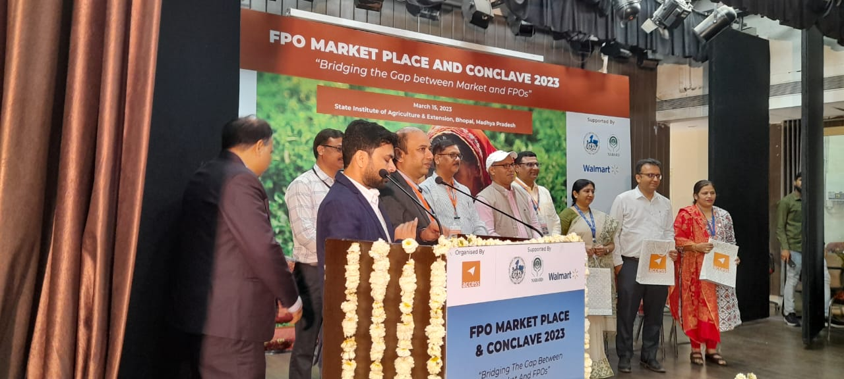**Mr. Rajat Vardhan** discussed the prospects of use of technology by FPOs. According to him, there are two categories of technology: 1. Hardware base technology 2. The use of digital technology. In addition, he provided the following 2-3 benefits of the digital platform.
  + FPOs can increase their own incomes thanks to technology.
  + Time can be saved, and produce quality can be raised.

Further he went on to explain how startups can collaborate with FPOs and how doing so will benefit FPOs in the future, He stressed to make it essential for FPOs to partner with startups.

**Prof. Manisha Pandey** summarized the the panel discussion revolved around awareness on quality parameters required by the private sector, delivering consistent quality within the agreed timelines, government support and schemes to aid the FPOs in primary processing of produce including support from Agri Infrastructure Fund to deliver the required quality of produce etc. The discussions with the eminent panelists were very much enriching and will work towards helping the FPOs connect with the relevant ecosystem players. These initial steps will work towards creation of long-term sustainable relationships.

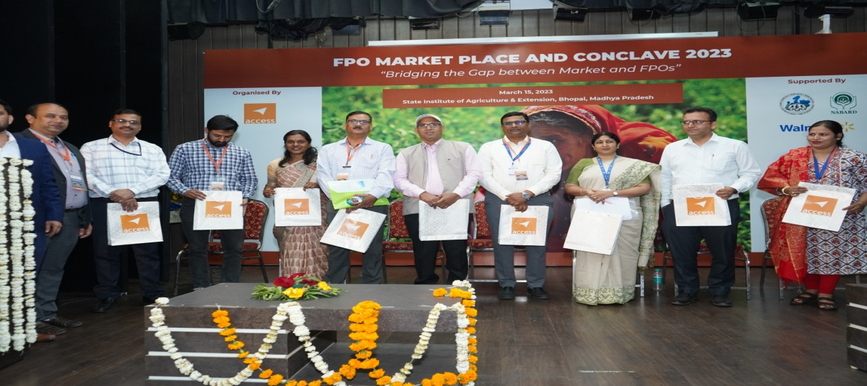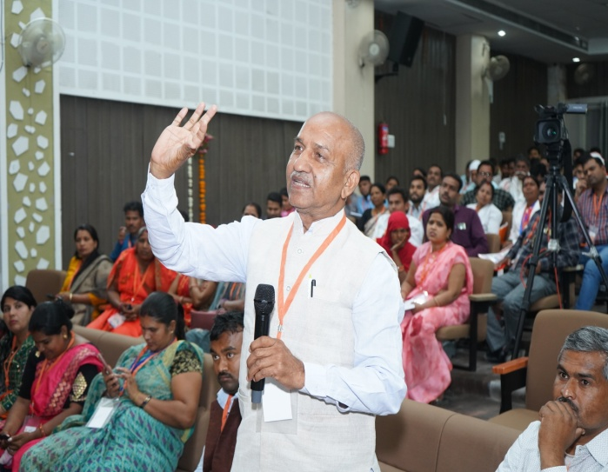

1. **Creating Sustainable Market Linkages for FPOs**

**Panelist:**

* Mr. Salil Kumar Jenna, VP, ACCESS Development Services; (Moderator)
* Mr. Anjan Mandal, Head-Farmer Brands, Innotera
* Ms. Nirmala Rathor, BoD ,Vijayganj Mandi FPC ltd.
* Ms. Chintamani Patidar, Director, Vijayganj Mandi FPCL
* Mr. Malay Kumar Mehar, AGM-NABARD
* Mr. Himanshu Pratap Singh,Head-Output Business, BEAM
* Mr. Vinay Choudhary, VP – FPO Market Linkage and e-Mandi, Agribazaar
* Mr. Vikas Panday, State Head, NBHC

Mr. Salil Jenna welcomed the panelistsand opened the panel discussion with brief expectations.

* **Mr. Anjan Mandal** talked on the secondary processing aspects and how important packaging is to capture a good market for FPOs. He expressed his views on packaging and digital marketing and shared Innotera work on the same with some examples of packaging on almonds and other nuts in association with many FPCs. He briefed about the scope to work with FPCs through Innotera digital market platform where FPOs can adopt strategy though their own pricing of their produce. He briefed about Innotera capacity and reach such that -1. Network of 12 thousand retailer, have digital market Platform, Works on 3-4 model which includes quality, pricing and packaging, has worked more on spices like, almond etc. and welcomed the FPOs participants to onboard with them.

**On replying to** FPO’s representative question- whether he can work with you on the production of linseed, He replied we are planning and will work with you further on linseed.

In response to the following query, where is the Innotera warehouse located and is it a chargeable facility, he replied they are located in many places in Madhya Pradesh and share the list with organizers and told they are not chargeable. Answering to the next question which came from Gohad FPC- do they work on Mushroom, he replied politely with no and told they are planning to work on coriander in the future and good scope to work on Mustard in MP.

* 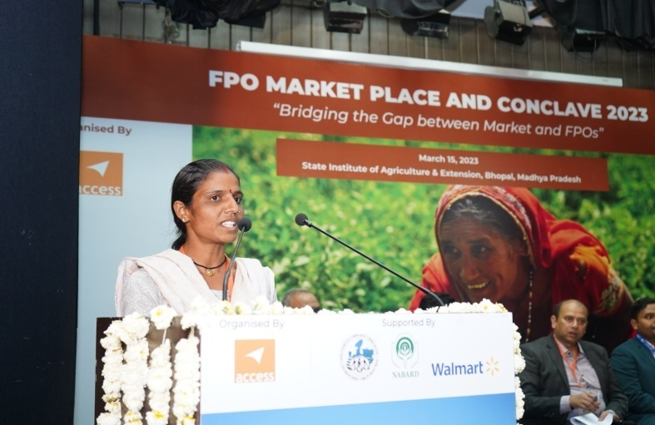**Ms. Nirmala Rathor** Board of Director, shared her journey with FPO and said that when FPO was established, there was a lot of problem in doing each and every work, later organizations like MPSRLM, NABARD, and ACCESS Development Services supported them. Further, thanking Access, she said that today we got a chance to speak on the problems related to FPO on such a big platform. She told that today turnover of his FPO is reached to Rs. 1 crore, working on potato Papad and chips and to sell them at retail stores. She also shared business planning the FPO.
* **Mr. Malay Kumar Meher** shared about the Challenges of market linkage in NABARD supported FPO and emphasized that the biggest challenge is the infrastructure.He informed about Agriculture Marketing Infrastructure Fund in which FPO can get subsidy, FPOs can take loan from banks, in which they lack information, for which Didiya can contact Horticulture Department.He stressed upon that there should be market intelligent in FPO who should have daily knowledge of market rate, mandi rate. Adding on to NABARD supports to FPOs he told that NABARD is bridging the infrastructure gap with FPOs and expressed his thought that there must be FPO’s Sustainable Production Analysis understanding on the quality requirement that needs to be worked upon.
* **Mr. Himanshu** talked about the commodity procurement choices of both the buyer and the seller. He expressed his views that if the quality is good in the FPO, then the rate will be good in the market. The direct source of FPO should be from the company, not from the mediator. On answering to a participants question of varying and lower prices of commodities, quoting the example of some commodity he told that there are various factor and different origin source as well to fix the rates.
* **Mr**. **Vinay Chowdhary** about the various models with which Agribazaar is working with FPOs on different dimension. Counting on to achievement of Agribazaar, working with FPOs he told that transactions worth 250 crores have been completed, have 10 thousand tons commodities are in their warehouse,notified area has e-market, Agribazaar itself operates Mandi. He said that AgariBazaar is a digital platform which is being supported by the government since 2017. He stressed on 3 points strategy for growth of FPOs -FPO needs to be digital; FPO choose good organization for linkages; FPO works on good quality of crop. Thanking to ACCESS in the end, he said that through this event, the problems and other issues of FPO came in front and FPO got a big platform from this Buyer Seller Meet.
* **Mr. Vikash Pandey** thanking to ACCESS expressed his gratitude to provide such a platform which reduces the buyer-seller gap.He further told about NBHC works of providing storage facilities to traders and mandi agent and they have tie-up with 51 Banks for availability of finance.

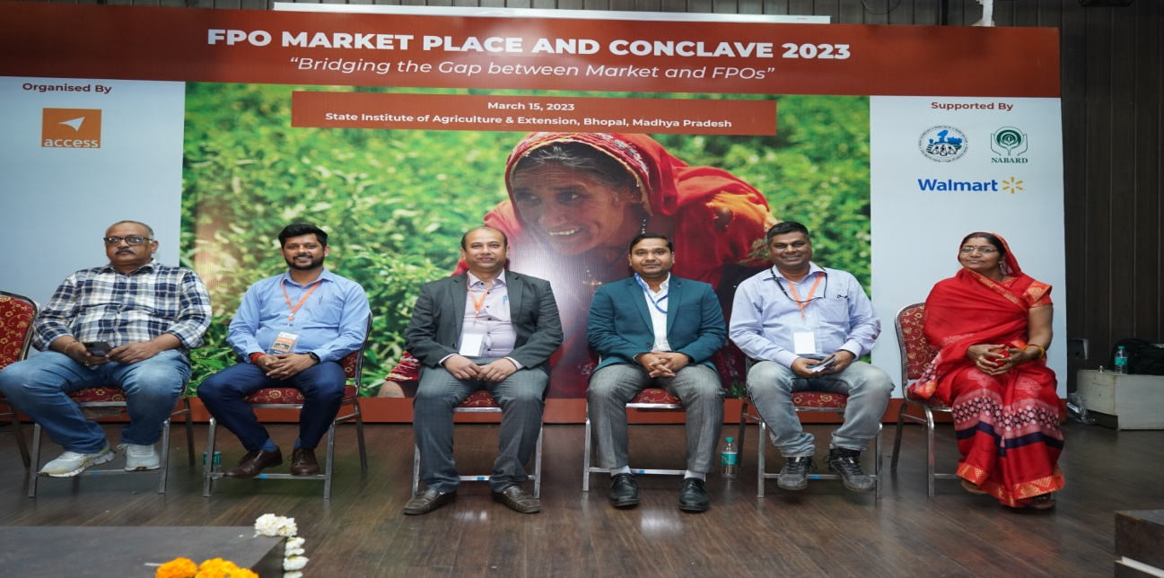

1. **Financing for FPOs**

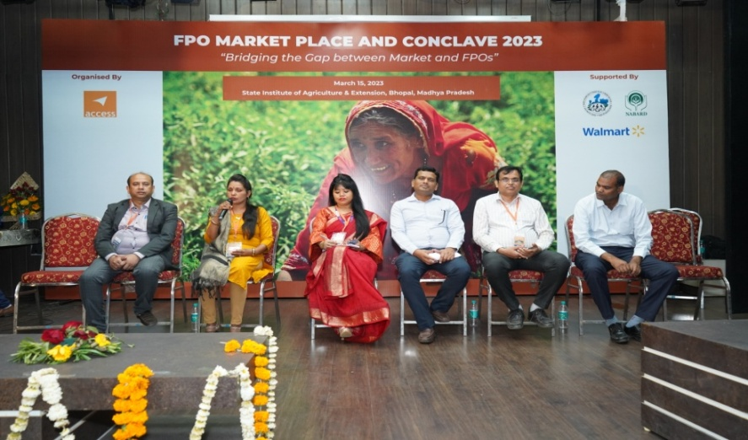 **Panelist:**

* Mr. Salil Kumar Jenna, VP, ACCESS Development Services; (Moderator);
* Mr. Mr. Rajnish Sentu, VP-Business, Samunnati,
* Mr. Deependra Singh, Head-Insurance Business, AISECT, Bhopal,
* Dr. Ratnabati, CPT, State Bank of India;
* Mr. Deepak, BDM NABKISAN,
* Ms. Savita Kashyap, BoD, TekriMahila FPC Guna.

Mr. Salil Kumar Jenna welcomed the panel membersand expressed the hope the discussion would identify the challenges of the FPOs in Madhya Pradesh and contribute to solving the very important issue of FPOs financing.

The panelists were given the floor one by one. The following are key recommendations from panelists.

* **Ms. Savita Kashyap** shared her FPO journey and discussed the challenges of financial constraints and the impact due to that on their planning and business that her FPO is facing. She stated that there must be a long-term solution in this direction and hoped that the panellists would reach a conclusion.
* **Dr. Ratnabati** talked in detail how FPOs can approach the banks especially to SBI to ensure FPOs financing. She took various questions from the participants which was around their challenges to get financed from the banks she briefly avoided the confusions and guided the proper way to get financed from the banks.
* **Mr. Rajnish Sentu** discussed the financing challenges faced by FPOs and shared Samunnati initiatives aimed at reducing finance-related challenges for FPOs. He also spoke about the various financial products designed by Samunnati for FPOs.
* **Mr. Deppendra Singh** talked about the challenges for FPOs financing linking with the insurance problems. He mentioned that he came confronted with many FPOs who shared that FPOs face the financing issue due to unavailability of Mandi Licence. As we are aware that FPOs have to complete the process of FD. Further he shared about the AISECT and brief about its work. He stated that AISECT has been a leading social and commercial company for the past 40 years, as well as serving in the financing sector. We have assisted over 27 thousand entrepreneurs, including financial linkages. He mentioned that we have the platform where more than 500 services and FPOs may see the scope to use the technology from there.
* 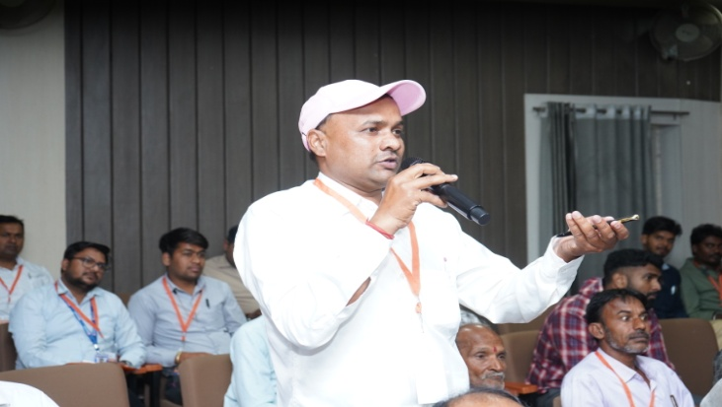**Mr. Deepak Malviya b**riefed about the NABKISAN services to the farmers and collectives of farmers in the financial sector.Answering to the questions of the participants regarding the interest loan, methods to charge the interest with respect to time, and others he told the interest rates, time frame for the charges etc.

At the end further questions were taken from the FPOs representatives and CBBOs and panelist responded to their questions.

At the end Mr. Salil concluded the discussion: Accessing finance is very important pillar to support the FPOs based on their requirement and appetite for accessing finance.  FPOs in MP are at three different stages – Early stage (to undertake basic business activities – capacity building, documentation activities, obtaining various licenses to undertake business activities), Emerging / growing stage (increase equity base and access working capital to undertake business), matured stage (term loans for business expansion).  
The discussions with the eminent panelists were very much enriching and will work towards helping the FPOs connect with the relevant ecosystem players. These initial steps will work towards creation of long-term sustainable relationships. Further he extended his gratitudeand thanked everyone for the participation.

### Vote of ThanksThank You Images - Free Download on Freepik

Mr. Salil Jenna expressed his gratitude towards each participants participated in the event. He spoke about the scope and aim and need for such events in future. After that representative from each FPOs trading organizations, government functionaries and given a small token of appreciations and the program has been ended with vote of thanks to all attendees.

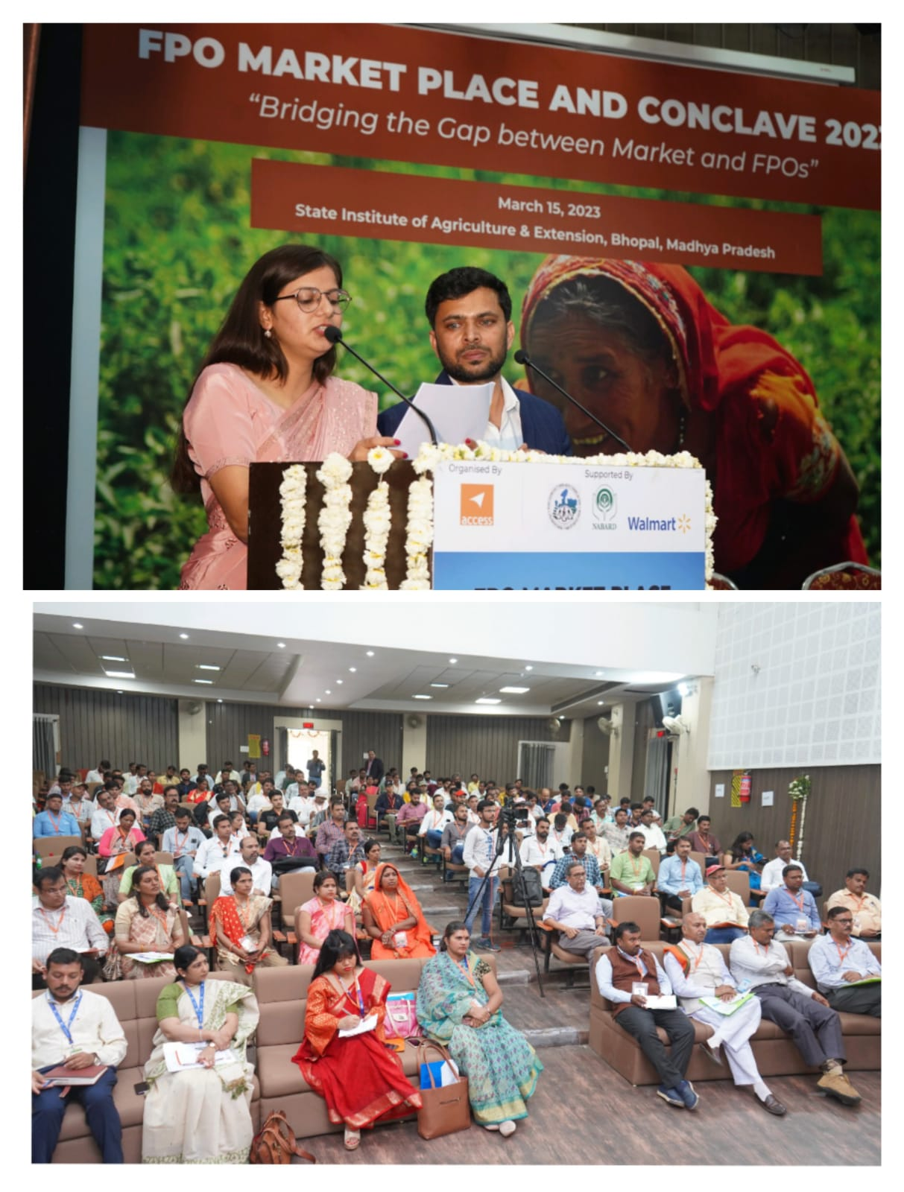

## Outcomes of the event-

The following were the major outcomes of the event:

* Multiple new collaborations took place for market linkages of FPOs. On an average FPOs representatives got chance to meet approx. 15 stakeholders such that traders, corporate buyers, input suppliers, agri-tech platforms, warehousing companies, tech-platforms, and institutional and technology partners. It will improve the business prospects for their FPCs.
* Showcasing and branding of the agri produces of Farmer Producer Companies to the market players who came from various part of the country.
* Bridged the knowledge gaps, raised awareness among the FPOs about the opportunities for new business avenues with the market players- Ag-tech platforms. During panel discussions, discussion revolved around awareness on quality parameters required by the private sector, delivering consistent quality within the agreed timelines, government support and schemes to aid the FPOs in primary processing of produce including support.
* Many FPOs and their representatives and CBBOs shared the challenges today FPCs are facing. Suggestions came forward that the problems and issues FPOs are experiencing and raised through this market place event by FPOs representatives and CBBOs should be well documented and escalated further.
* Departments representatives emphasized that there should be such a scheme in the departments in which FPOs have provision of financial supports in the budget so that the department can support the FPOs in its annual plan.
* Need of a critical examination of the necessity of FPO [policy](https://www.linkedin.com/feed/hashtag/?keywords=policy&highlightedUpdateUrns=urn%3Ali%3Aactivity%3A7042131448333516800) in addressing APMC challenges and input allocations, particularly fertilizers to FPOs is realized by the Dignitaries, departments, civil societies and CBBO/FPO representatives.

**Women Empowerment**

* Event gave opportunity to women led FPCs to showcase the emerging women power and acknowledged their economic contribution to the economy though the FPOs platforms.
* Recently, the Self Help Groups movement has given a new impetus to this effort by empowering women and providing a legal framework for Farmer Producer Companies.
* Keen on taking the focus of Self Help Groups (SHGs) beyond member savings and internal loaning with bank linkages, the Madhya Pradesh State Rural Livelihood Mission or Ajeevika Mission decided to form Farmer Producer Company after assessing its potential in the region.
* Though women dominate various spheres of farming, their contribution has been largely neglected. But today, BoDs of Vijayaganj Mandi Farmer Producer Company Limited like companies consists progressive women farmers.
* Women from the poorer sections of society, as well as small and marginal farmers, from various segments of society, are among the company's shareholders, which represents the inclusiveness approach of the company.
* FPCs are engaging with Various marketing platforms and agricultural technology platforms to make them aware of price, risk management etc. Success stories of women led FPCs are coming to the fore.
* The story of Vijayganj Mandi FPC and Bhagyoday Farmer Producr company ltd like FPCs are awe inspiring. Going beyond traditional localised marketing today it is highly successful in marketing their produce to institutional buyers and provide much higher returns to hundreds of member farmers.
* The example of Nirmala Rathore like Didis a daily wager struggling to feed her family a few years ago, with a small piece of land and laden with huge debt of the local moneylender is inspirational.
* 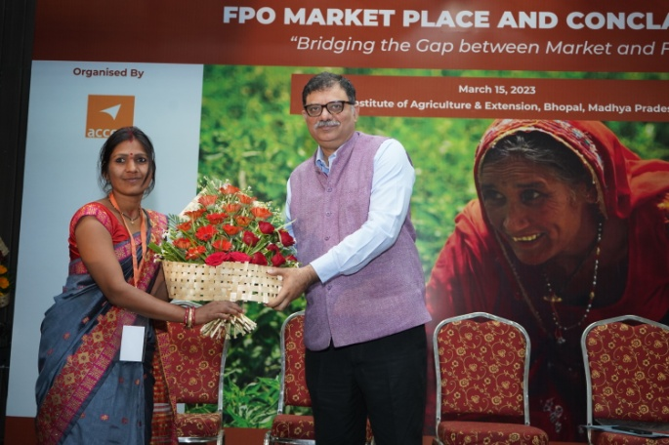Today these women farmers are dynamic board members of women Farmer Producer Companies. Didis are today sharing munch with dignitaries in big patforms and sharing their stories of FPCs journey. They are going ahead with having discussion with companies CEOs and representatives and further making tie-ups, signing MoUs to paving the way for FPOs business.
* With these examples of success stories of women led FPCs, It has been realized by all We need more focus on developing and supporting women led FPOs which will have a multiplier effect on agriculture, families and rural economy.
* 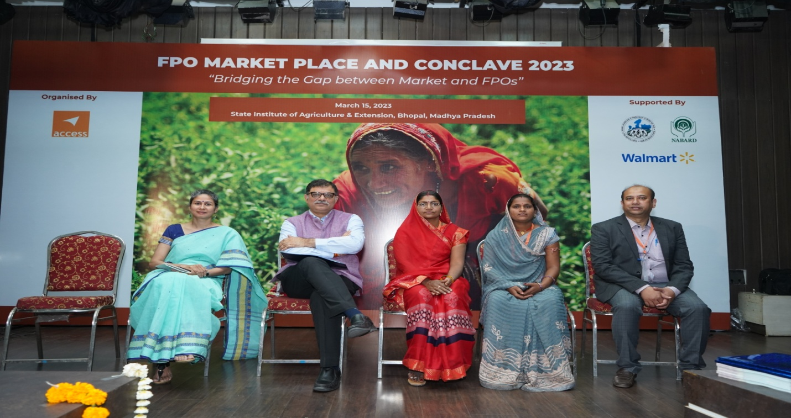Specific policy support that recognises women led FPCs can pave the way to make them the beacon of women empowerment.

## Way ahead-

### Follow up with Market functionaries for tie ups

* ACCESS committed to accessing the FPOs' capacities, identifying their needs, and designing a path to serve them at various milestones. We will not stop unthis event is over. This is the beginning of our journey to scale our operations.
* In our next step we will build the partnership with government stakeholders, financial & market linkage/technology partners. Established and facilitated their regular communications & business engagements.
* After initially investing in technology things get systematic, FPOs/farmers can see things clearly such as when farmers sowed their crop, when irrigation is required, and when they can expect crop to be harvested. And anybody can track this. So there are advantages, and technology driven models are promising and for that ACCESS Development Services will begin by piloting with a small number of FPOs, who have financial capacities to afford the technology services.
* ACCESS will propose revenue models where ag-tech companies and FPOs may come together. Revenue model will consist a business plan in which we state that if FPOs invest this much in technology, FPO will earn that much of benefit. For the purpose of better efficiency, FPCs may be taken in the different agro climatic zone.
* If the FPC agrees and sees the potential, a Memorandum of Understanding will be signed with tech companies.

### Zoom meets for participants with market functionaries

* Following the event, ACCESS Development Services proposes to conduct a series of physical and virtual meetings between FPO representatives and traders, corporate buyers, input suppliers, agri-tech service providers, warehousing companies, tech-platforms, and institutional and technology partners to discuss specifics and move the partnership forward.
* ACCESS Development Services will assist in identifying Farmer Producer Companies that may be interested in collaborating with aforementioned stakeholders and assist in completing the MoUs.

### Sending a note to ACS Agriculture for event proceedings and outcome

ACCESS Development Services will send proceeding of the event with major outcomes and suggestion to seek the departmental support from Department of Agriculture and Farmer Welfares. The major outcomes of the event are summarised in the preceding section of the document.

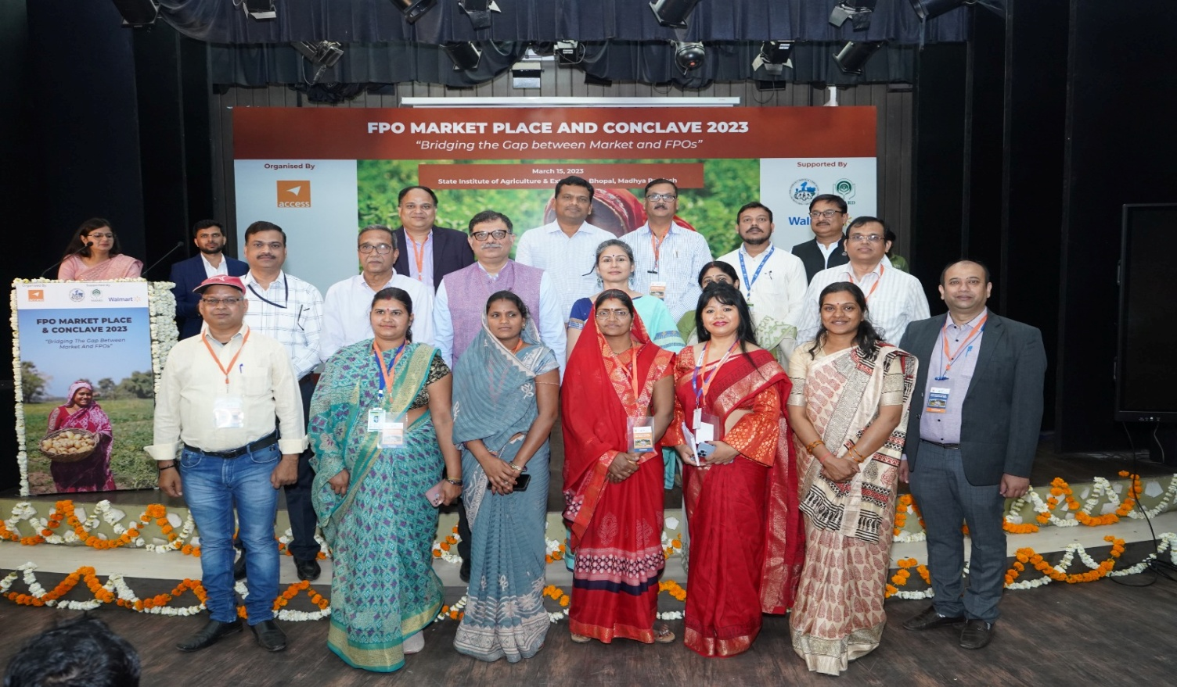 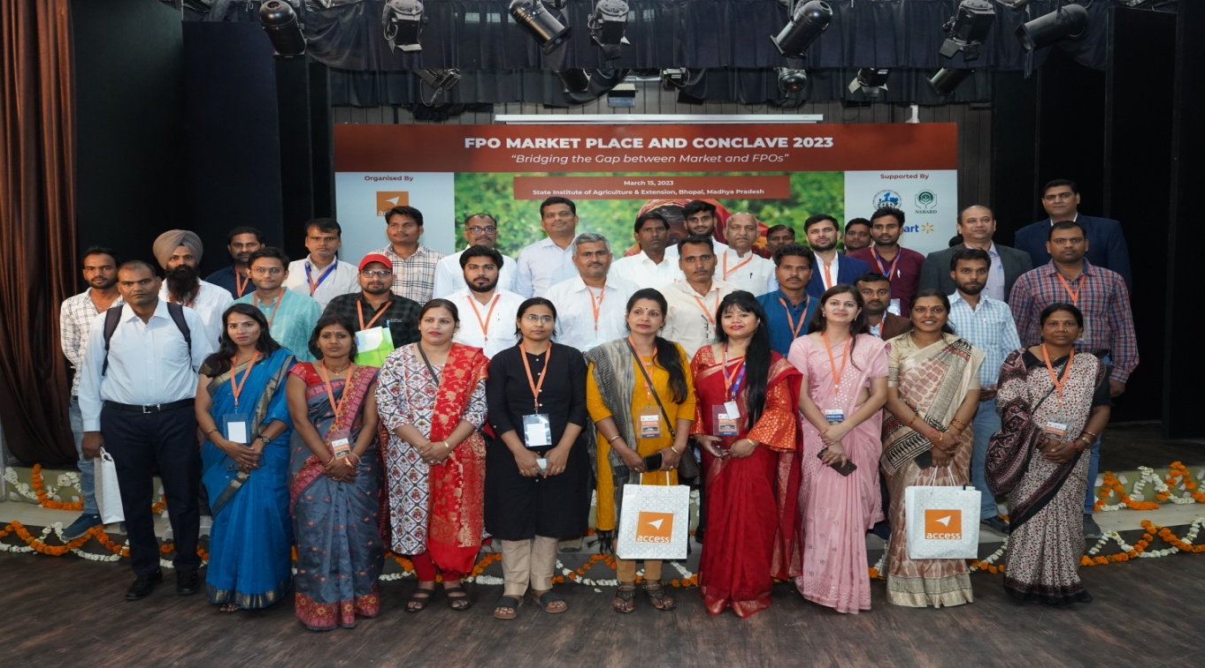

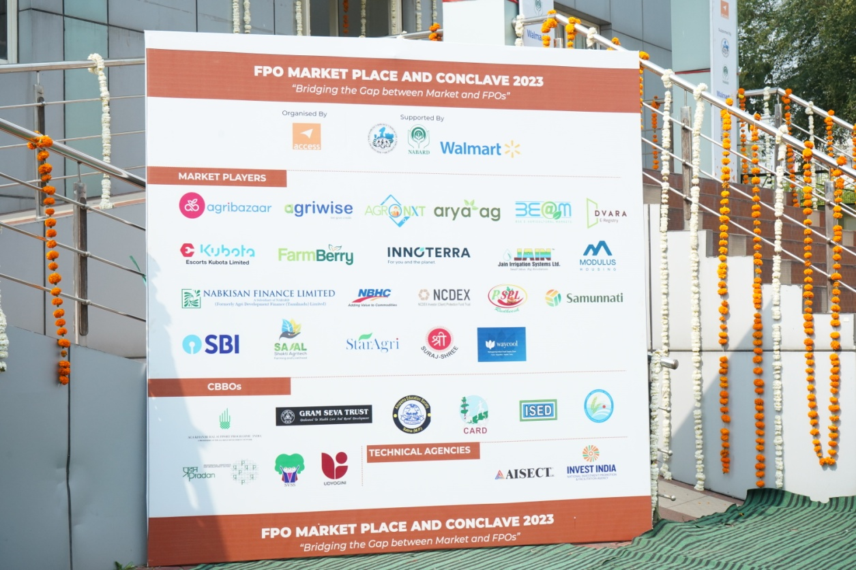

……………………………………………………….Thanks……………………………………………………….